**Expiriment NO: 7**

**Aim : Familiarisation of linux commands**

**CO2 : Perform system administration task**

procedure :

**1)expr**

Evaluate the given expression and display the output.

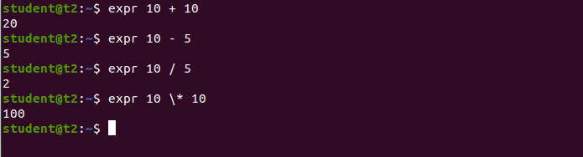

**2) df**

df is used to get a report on system’s disk space usage.

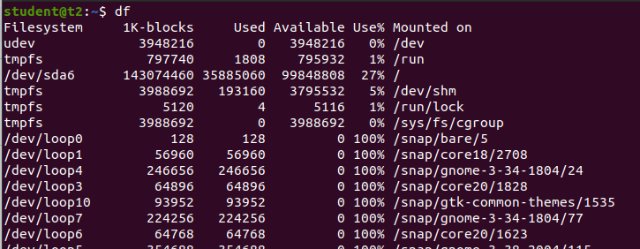

**3)du filename**

du is used to check how much space a file or directory takes in the current directory.

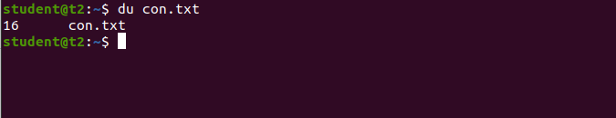

**4)sudo useradd username**

To create a new user.

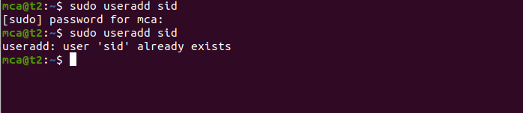

**4.1)sudo passwd username**

To update password.

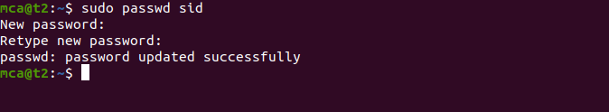

**5)sudo groupadd -g identifier groupname**

Used to create new group.

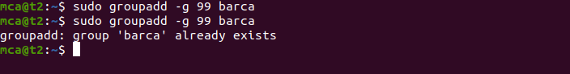

**6)sudo usermod -G groupname username**

To assign users to a group.

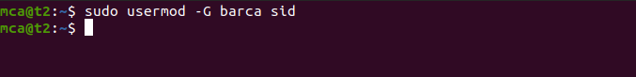

**7)id username**

To display user informations.

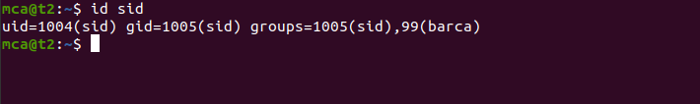

**8)compgen -g**

Used to display all the groups.



**9) chmod -wx filename**

chmod is used to change the access permissions of files and directories,it stands for change mode.

read(r)

write(w)

execute(x)

denying the permissions

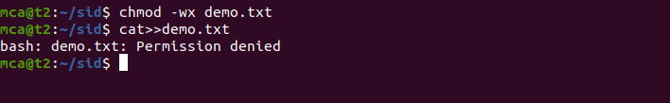

allowing permissions

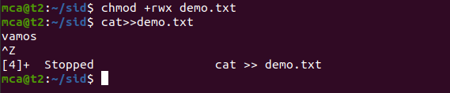

**10)sudo chown username filename**

To change the file or directory ownership for a user or a group,chown stands for change owner.

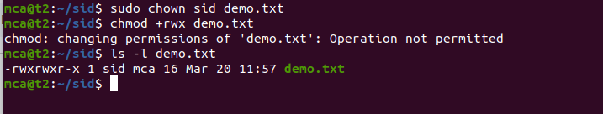

**11)sudo userdel username**

Used to delete user.

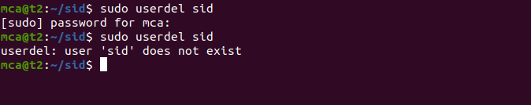

**12)sudo groupdel groupname**

Used to delete groups.

